# Exercises: How to use Cindicator application

This documents describes the exercise assignments for the ["Blockchain Academy" course @ Software University](https://softuni.bg/courses/programming-fundamentals). In this lesson, we learned about Notable Blockchain Projects. As mentioned one of them is Cindicator. In this exercise, we download Cindicator application, register in it and play with the Cindicator app. Then we will learn how to make forecasts in Cindicator. Examples are given in the iOS platform.

## Download Cindicator application

1. The first thing we'll need is to download the application

Go to <https://cindicator.com/>

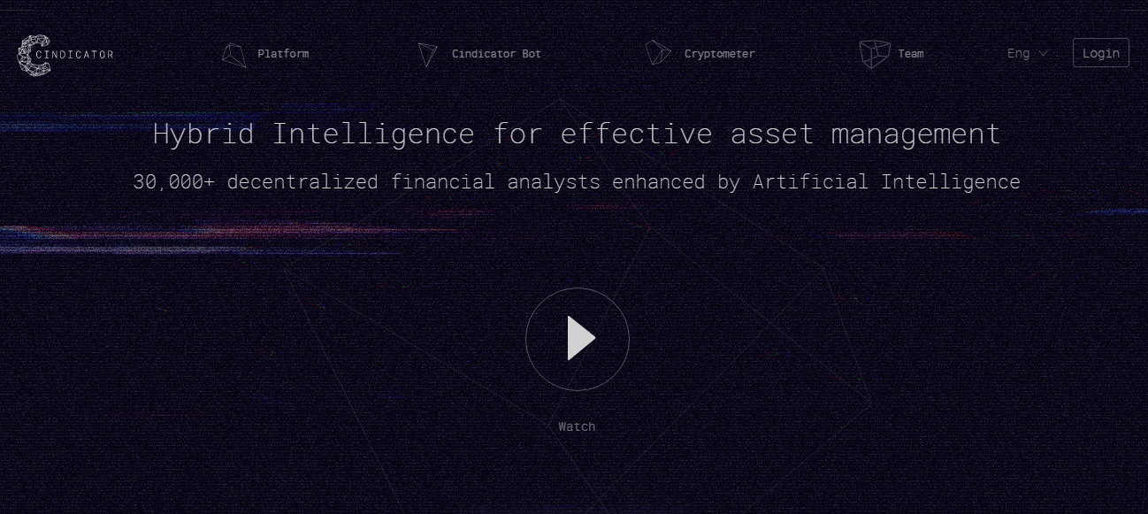

1. Click [**Sign up**] and create your profile or [**Login with Facebook**]

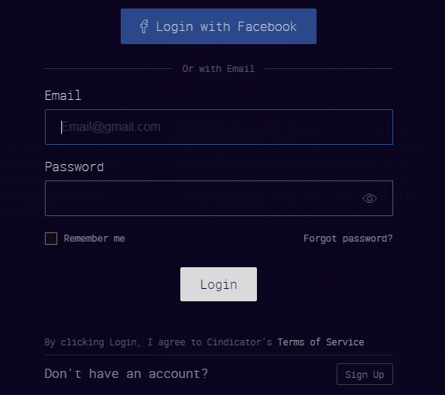

1. This is the land page of the Cindicator prediction market

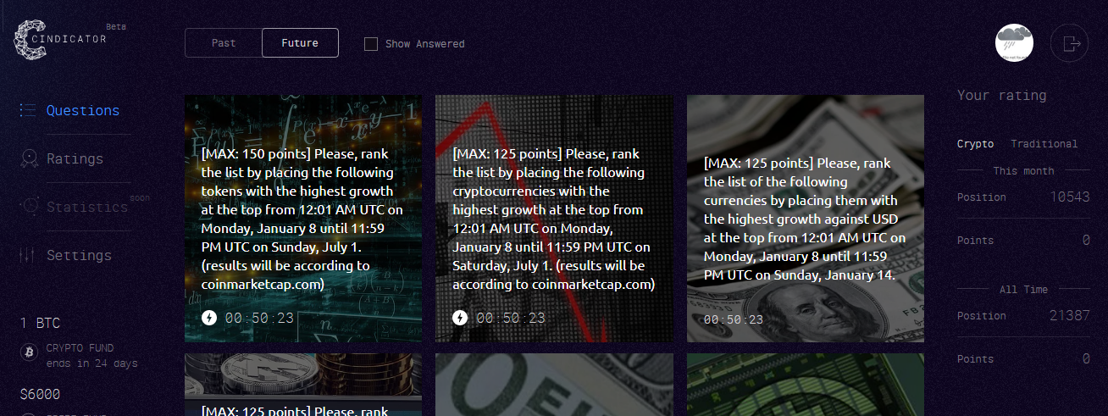

1. You can click on [**Questions**]. Here you can find all the questions related to cryptocurrency and stock market.

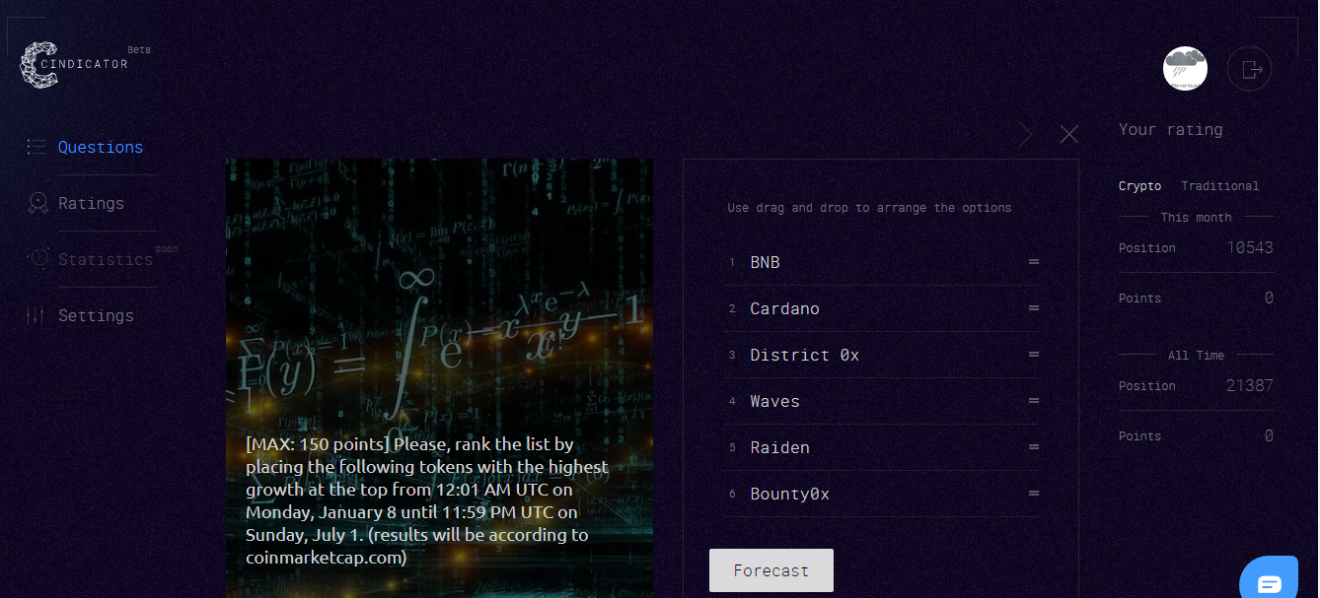

1. Now you can answer the question by arranging those six cryptocurrencies and click [**Forecast**].
2. On the [**Ratings**]tab, you can see the top forecasters

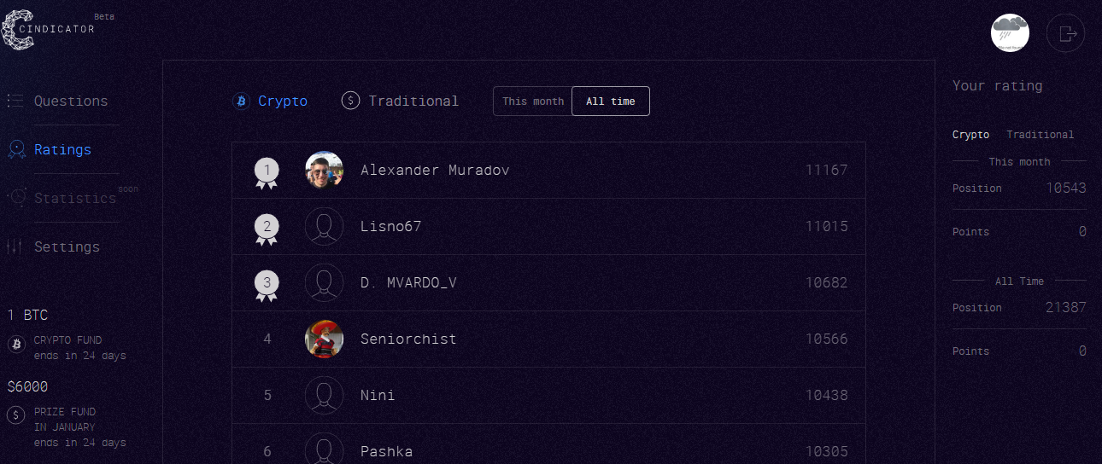

1. On the right, you can see your rating and points.

## Download mobile application Cindicator

1. Go to <https://cindicator.com/> and download the application for your iPhone or Android mobile

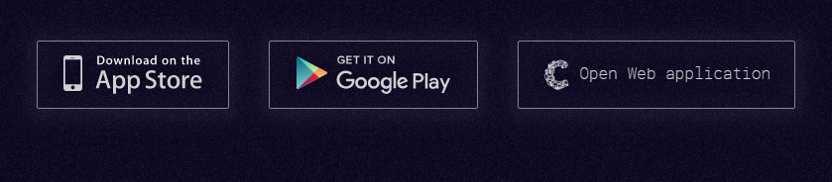

1. Menu bar is the same as the desktop version.

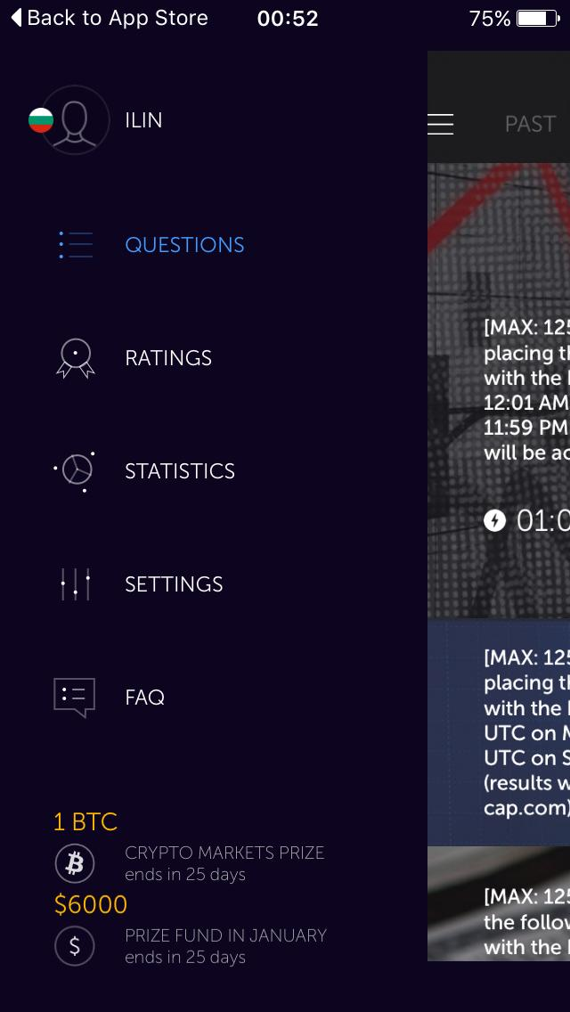

1. You can find the same question. Mobile application is easy as you can **Forecast** on the go

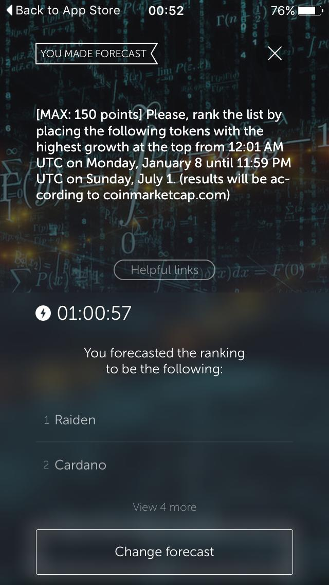

Reward for the minimum viable action (MVA)

Now all analysts who finish the month with at least one positive score will be eligible for financial compensation. Thereby, each point earned increases the total reward for the analyst in accordance with the entered group, which we call “stake”. To withdraw the prize money to your wallet, you will need to accumulate an amount equivalent to $10 or more. Do not worry if you won less than $10 — your points will be kept for the next month.